**MINI PROJECT REPORT**

**ON**

**Arduino based Hand Gesture Control of Your Computer**

Submitted in partial fulfillment of requirements to

CB 352 Mini Project

III/IV B. Tech CSBS (V Semester)

By

Y21CB036 - M.SAI DEEPAK

Y21CB047 - A.SAI CHARAN

Y21CB059 - V.CHETAN



**December 2023**

**Department of Computer Science and Business Systems**

**R.V.R & J.C. COLLEGE OF ENGINEERING**

**(AUTONOMOUS)**

**(Approved by A.I.C.T.E) NAAC ‘A+’ Grade**

**(Affiliated to Acharya Nagarjuna University)**

**Chandramoulipuram: Chowdavaram ,GUNTUR – 522 001**

**R.V.R & J.C. COLLEGE OF ENGINEERING**

**DEPARTMENT OF COMPUTER SCIENCE & BUSINESS SYSTEMS**



**BONAFIDE CERTIFICATE**

**This is to Certify that this Mini Project work entitled “ Arduino based Hand Gesture Control of Your Computer” is the bonafide work of M.SAI DEEPAK (Y21CB036), A.SAI CHARAN(Y21CB047), V.CHETAN (Y21CB059) of III/IV B.Tech who carried the work under my supervision, and submitted in the partial fulfillment of the requirements to CB352 - MINI PROJECT LAB REPORT during the year 2022-2023.**

**Dr.Ch.Sudha Sree Sri P.Srinivasa Rao**

**(Project Guide) (Project Incharge)**

**Dr.M.V.P.Chandra Sekhara Rao**

**Prof. & Head,Dept. of CSBS**

**ACKNOWLEDGEMENTS**

From the idea to the act, from the conception to reality, from the emotion to the response, from the desire to the spasm, we are led by those about whom to write all words seem meek.

We are very much thankful to Dr. Kolla. Srinivas, Principal of R.V.R. & J.C College of Engineering, Guntur, for allowing us to work on this project.

We express our sincere thanks to Dr. M.V.P. Chandra Sekhara Rao, Professor and Head, Department of Computer Science and Business Systems for encouraging and suppo rting us to carry out this project successfully.

We are very glad to express our special thanks to Dr.Ch.Sudha Sree, Mentor who has inspired us to select this project according to our choice and for his valuable advice to work on this project.

This Mini Project wouldn’t be completed without the help of my friends, family members and other people who are directly or indirectly connected with this work. I also express my sincere thanks to the Technical and Non-Technical staff and all the faculty of the department for their valuable help.

M.SAI DEEPAK(Y21CB036)

A.SAI CHARAN(Y21CB047)

V.CHETAN (Y21CB059)

**CONTENTS**

Chapter No & Name Page No.

1.Abstract 5

2.Introduction 6

3.Principle behind project 8

4.Block diagrams 9

5.Design of project 10

6.Code Snippets 12

7.Results 18

8.Impact of the project 19

9.Applications 20

10.Future scope & conclusions 22

11.Bibliography 23

**Arduino based Hand Gesture Control of Your Computer**

**1.ABSTRACT:**

This project introduces an advanced IoT-enabled system for laptop control via hand gestures, harnessing Arduino microcontrollers and ultrasonic sensors. The framework leverages ultrasonic sensors to capture intricate hand movements, transmitting this data to an Arduino board. Employing sophisticated algorithms, the Arduino interprets these gestures, mapping them to predefined commands for laptop interaction. Gestures such as swipes, rotations, and hand positioning are recognized and translated into actions like cursor movement, clicking, and scrolling on the laptop screen.

The system's IoT integration allows for seamless connectivity between the Arduino-based gesture recognition unit and the laptop, enabling real-time data exchange. This bidirectional communication enables not only gesture interpretation but also feedback to the user. By utilizing IoT protocols, such as MQTT or Wi-Fi, the system ensures efficient and reliable transmission of gesture-based commands.

This innovative approach merges hardware and software intricacies, offering a non-intrusive, intuitive means of controlling laptops through gestures. The amalgamation of Arduino's processing capabilities, ultrasonic sensor precision, and IoT connectivity establishes a sophisticated yet accessible interface for users. Furthermore, this system's adaptability permits potential expansion to encompass diverse gesture sets or integration with various applications, fostering a dynamic, hands-free computing experience. Overall, this research signifies a leap in human-computer interaction,

emphasizing intuitive gestural interfaces for enhanced accessibility and usability in computing realms.

**2.INTRODUCTION:**

The project 'Arduino-based Hand Gesture Control of Your Computer' represents an innovative fusion oftechnology and human-computer interaction, aiming to revolutionize conventional interfaces. In a world where seamless interaction with technology is increasingly vital, this project explores the integration of Arduino microcontrollers and ultrasonic sensors to facilitate hands-free computer control through intuitive hand gestures.

The fundamental objective of this project is to establish a novel, non-intrusive means of interfacing with computers. By harnessing the precision of ultrasonic sensors to detect and interpret hand gestures, coupled with the computational power of Arduino boards, this system transcends traditional input devices. Users can effortlessly navigate, click, and scroll through computer interfaces without physical touch, making computing more accessible and ergonomic.

This project delves into the realms of gesture recognition, sensor data processing, and real-time interaction protocols. It seeks to bridge the gap between technology and user convenience, striving to offer an intuitive and user-friendly alternative to conventional input methods. The significance lies not only in its technical complexity but also in its potential to enhance accessibility for individuals with physical limitations, revolutionizing the way people interact with computers.

This introduction sets the stage for an exploration into the intricacies of combining hardware, software, and human-computer interaction principles to create an innovative system that redefines the boundaries of user interface design.

You might have seen Hand Gesture Controlled Robots, where the motion of a robot is controlled by the gestures of the hand. Another interesting project based on a similar principle is an Arduino based Hand Gesture Control of your computer or laptop.

Human Machine Interface or HMI is a system comprising of hardware and software that helps in communication and exchange of information between the user (human operator) and the machine.

We normally use LED Indicators, Switches, Touch Screens and LCD Displays as a part of HMI devices. Another way to communicate with machines like Robots or Computers is with the help of Hand Gestures.

Instead of using a keyboard, mouse or joystick, we can use our hand gestures to control certain functions of a computer like play/pause a video, move left/right in a photo slide show, scroll up/down in a web page and many more.

In this project, we have implemented a simple Arduino based hand gesture control where you can control few functions of your web browser like switching between tabs, scrolling up and down in web pages, shift between tasks (applications), play or pause a video and increase or decrease the volume (in VLC Player) with the help of hand gestures.

### **3.Principle behind the Project:**

The principle behind the Arduino based Hand Gesture Control of Computer is actually very simple. All you have to do is use two Ultrasonic Sensors with Arduino, place your hand in front of the Ultrasonic Sensor and calculate the distance between the hand and the sensor. Using this information, relevant actions in the computer can be performed.

The position of the Ultrasonic Sensors is very important. Place the two Ultrasonic Sensors on the top of a laptop screen at either end. The distance information from Arduino is collected by a Python Program and a special library called PyAutoGUI will convert the data into keyboard click actions.

**4.BLOCK DIAGRAM:**

**CIRCUIT DIAGRAM:**

The circuit diagram of Arduino part of the project is shown in the following image. It consists of an Arduino UNO board and two Ultrasonic Sensors and you can power up all these components from the laptop’s USB Port.

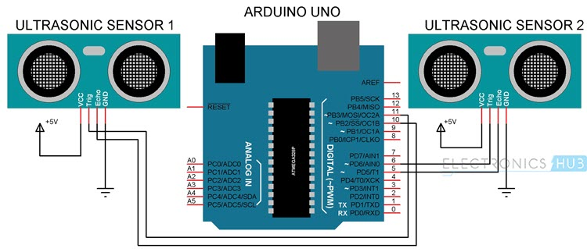

### Components Required

* Arduino UNO x 1
* Ultrasonic Sensors x 2
* USB Cable (for Arduino)
* Few Connecting Wires
* A Laptop with internet connection

**5.Design of the Project:**

Now, coming to the placement of the Sensors, place both the Ultrasonic Sensors on top of the Laptop screen, one at the left end and the other at right. You can use double sided tape to hold the sensors onto the screen.

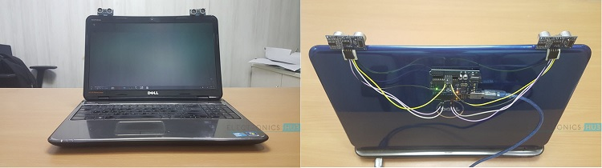

Coming to Arduino, place it on the back of the laptop screen. Connect the wires from Arduino to Trigger and Echo Pins of the individual sensors. Now, we are ready for programming the Arduino.

### **Programming Your Arduino to Detect Gestures:**

The important part of this project is to write a program for Arduino such that it converts the distances measured by both the sensors into the appropriate commands for controlling certain actions.

We have already seen a project called [**PORTABLE ULTRASONIC RANGE METER**](https://www.electronicshub.org/portable-ultrasonic-range-meter/), where you can measure the distance of an object placed in front of an Ultrasonic Sensor with the help of Arduino.

A similar concept is used here to measure the distance of your hand in front of both the Ultrasonic Sensors in this project. The fun part starts after calculating the distance.

The hand gestures in front of the Ultrasonic sensors can be calibrated so that they can perform five different tasks on your computer. Before taking a look at the gestures, let us first see the tasks that we can accomplish.

* Switch to Next Tab in a Web Browser
* Switch to Next Tab in a Web Browser
* Scroll Down in a Web Page
* Scroll Up in a Web Page
* Switch between two Tasks (Chrome and VLC Player)
* Play/Pause Video in VLC Player
* Increase Volume
* Decrease Volume

The following are the 5 different hand gestures or actions that I’ve programmed for demonstration purpose.

**Gesture 1:** Place your hand in front of the Right Ultrasonic Sensor at a distance (between 15CM to 35CM) for a small duration and move your hand away from the sensor. This gesture will Scroll Down the Web Page or Decrease the Volume.

**Gesture 2:** Place your hand in front of the Right Ultrasonic Sensor at a distance (between 15CM to 35CM) for a small duration and move your hand towards the sensor. This gesture will Scroll up the Web Page or Increase the Volume.

**Gesture 3:** Swipe your hand in front of the Right Ultrasonic Sensor. This gesture will move to the Next Tab.

**Gesture 4:** Swipe your hand in front of the Left Ultrasonic Sensor. This gesture will move to the Previous Tab or Play/Pause the Video.

|  |
| --- |
| = |
|  |
|  |
|  |
|  |
|  |
|  |
|  |
|  |
|  |
|  |
|  |
|  |
|  |
|  |
|  |
|  |
|  |
|  |
|  |
|  |
|  |
|  |
|  |
|  |
|  |
|  |
|  |
|  |
|  |
|  |
|  |
|  |
|  |
|  |
|  |
|  |
|  |
|  |
|  |
|  |
|  |
|  |
|  |
|  |
|  |
|  |
|  |
|  |
|  |
|  |
|  |
|  |
|  |
|  |
|  |
|  |
|  |
|  |
|  |
|  |
|  |
|  |
|  |
|  |
|  |
|  |
|  |
|  |
|  |
|  |
|  |
|  |
|  |
|  |
|  |
|  |
|  |
|  |
|  |
|  |
|  |
|  |
|  |
|  |
|  |
|  |
|  |
|  |
|  |
|  |
|  |
|  |
|  |
|  |
|  |
|  |
|  |
|  |
|  |
|  |
|  |
|  |
|  |
|  |
|  |
|  |
|  |
|  |
|  |
|  |
|  |
|  |
|  |
|  |

**Gesture 5:** Swipe your hand across both the sensors (Left Sensor first). This action will Switch between Tasks.

**6.CODE SNIPPETS:**

**Arduino Code:**

**const int trigPin1 = 11;**

**const int echoPin1 = 10;**

**const int trigPin2 = 6;**

**const int echoPin2 = 5;**

**long duration;**

**int distance1, distance2;**

**float r;**

**unsigned long temp=0;**

**int temp1=0;**

**int l=0;**

**void find_distance (void);**

**void find_distance (void)**

**{**

**digitalWrite(trigPin1, LOW);**

**delayMicroseconds(2);**

**digitalWrite(trigPin1, HIGH);**

**delayMicroseconds(10);**

**digitalWrite(trigPin1, LOW);**

**duration = pulseIn(echoPin1, HIGH, 5000);**

**r = 3.4 * duration / 2; .**

**distance1 = r / 100.00;**

**digitalWrite(trigPin2, LOW);**

**delayMicroseconds(2);**

**digitalWrite(trigPin2, HIGH);**

**delayMicroseconds(10);**

**digitalWrite(trigPin2, LOW);**

**duration = pulseIn(echoPin2, HIGH, 5000);**

**r = 3.4 * duration / 2;**

**distance2 = r / 100.00;**

**delay(100);**

**}**

**void setup()**

**{**

**Serial.begin(9600);**

**pinMode(trigPin1, OUTPUT); utput:**

**pinMode(echoPin1, INPUT);**

**pinMode(trigPin2, OUTPUT);**

**pinMode(echoPin2, INPUT);**

**delay (1000);**

**}**

**void loop()**

**{**

**find_distance variable;**

**if(distance2<=35 && distance2>=15)**

**{**

**temp=millis();**

**while(millis()<=(temp+300))**

**find_distance();**

**if(distance2<=35 && distance2>=15)**

**{**

**temp=distance2;**

**while(distance2<=50 || distance2==0)**

**{**

**find_distance();**

**if((temp+6)<distance2**

**{**

**Serial.println("down");**

**}**

**else if((temp-6)>distance2**

**{**

**Serial.println("up");**

**}**

**}**

**}**

**else**

**{**

**Serial.println("next");**

**}**

**}**

**else if(distance1<=35 && distance1>=15)**

**{**

**temp=millis();**

**while(millis()<=(temp+300))**

**{**

**find_distance();**

**if(distance2<=35 && distance2>=15)**

**{**

**Serial.println("change. ");**

**l=1;**

**break;**

**}**

**}**

**if(l==0)**

**{**

**Serial.println("previous");**

**while(distance1<=35 && distance1>=15)**

**find_distance();**

**}**

**l=0;**

**}**

**}**

#### **Python Code:**

If everything goes well till now, you can proceed to write the Python Code. If you observe the Arduino Code given above, the Arduino sends out five different texts or commands through Serial Port upon detecting appropriate hand gestures. These commands are

* Next
* Previous
* Down
* Up
* Change

Using these commands along with few functions in PyAutoGUI (like hotkey, scroll, keyDown, press and keyUp), you can write a simple Python Code that will execute the following tasks of keyboard and mouse.

* Data = “next” – – > Action = Ctrl+PgDn
* Data = “previous” – – > Action = Ctrl+PgUp
* Data = “down” – – > Action = Down Arrow
* Data = “up” – – > Action = Up Arrow
* Data = “change” – – > Action = Alt+Tab

|  |  |  |
| --- | --- | --- |
|  |  | PYTHON CODE: |
|  |  | import serial |
|  |  | import pyautogui |
|  |  |  |
|  |  | Arduino_Serial = serial.Serial('com12',9600) |
|  |  |  |
|  |  | while 1: |
|  |  | incoming_data = str (Arduino_Serial.readline()) |
|  |  | print incoming_data |
|  |  |  |
|  |  |  |
|  |  | if 'next' in incoming_data: |
|  |  | pyautogui.hotkey('ctrl', 'pgdn') |
|  |  |  |
|  |  | if 'previous' in incoming_data: |
|  |  | pyautogui.hotkey('ctrl', 'pgup') |
|  |  | if ‘down' in incoming_data: |
|  |  | pyautogui.scroll(-100) |
|  |  |  |
|  |  | if 'up' in incoming_data: |
|  |  | pyautogui.scroll(100) |
|  |  |  |
|  |  | if 'change' in incoming_data: |
|  |  | pyautogui.keyDown('alt') |
|  |  | pyautogui.press('tab') |
|  |  | pyautogui.keyUp('alt') |
|  |  |  |
|  |  | incoming_data = ""; |

**7.RESULTS:**

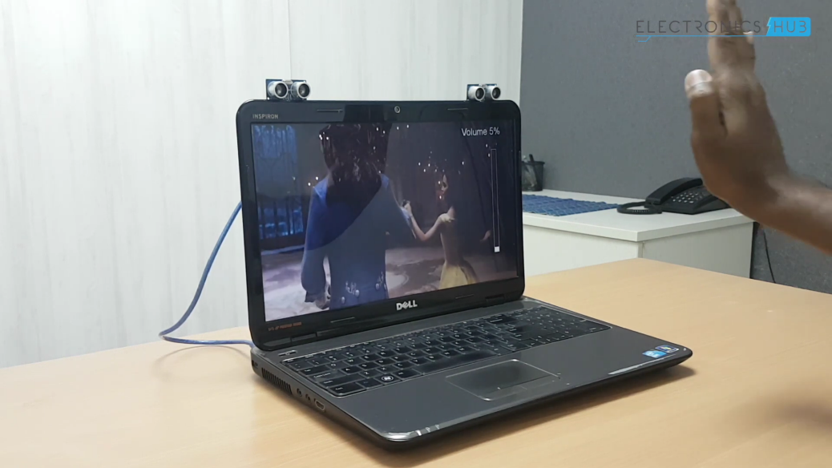

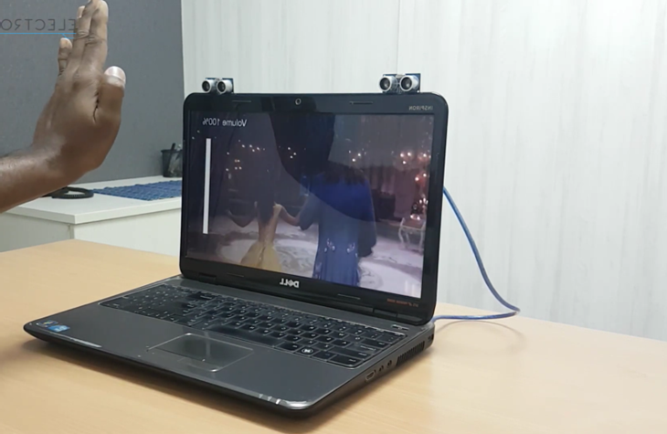

**8.IMPACT OF PROJECT:**

The project, Arduino-based Hand Gesture Control of Your Computer, carries substantial implications and potential impacts across various domains. Firstly, it revolutionizes human-computer interaction by introducing an intuitive, hands-free interface. This innovation reshapes how users navigate and interact with computers, fostering a more natural and ergonomic computing experience.

Beyond convenience, the project holds significant implications for accessibility. By enabling computer control through hand gestures, it empowers individuals with physical disabilities or limitations, offering an alternative interface that transcends traditional input devices. This inclusivity aligns with the principles of universal design, ensuring technology is accessible to a wider spectrum of users.

Moreover, this technology has the potential to redefine workplace ergonomics. By reducing reliance on traditional input peripherals, it mitigates repetitive strain injuries associated with prolonged mouse and keyboard usage. This shift towards gesture-based control aligns with ergonomic principles, potentially enhancing user comfort and productivity in work environments.

In educational settings, this project opens doors to interactive and engaging learning experiences. It introduces students to innovative technologies, inspiring curiosity and creativity in exploring the realms of electronics, programming, and human-machine interfaces.

Furthermore, in the broader context of technological advancements, this project lays the groundwork for future developments in gesture-based interfaces. Its success paves the way for refined gesture recognition systems, potentially influencing the evolution of user interfaces across various devices and applications.

Ultimately, the impact of this project extends beyond its immediate application. It represents a step forward in leveraging technology to create inclusive, user-centric interfaces, shaping a future where interactions with computers are seamless, accessible, and fundamentally intuitive.

**9.APPLICATIONS:**

The application potential for the project, Arduino-based Hand Gesture Control of Your Computer, spans across numerous fields, showcasing its versatility and adaptability.

In the realm of healthcare, this technology holds promise for creating assistive devices for individuals with physical disabilities. It could be integrated into systems that enable disabled individuals to control their computers, facilitating communication, learning, and entertainment without relying on conventional input devices.

In industries, particularly manufacturing and automation, this gesture control system could streamline processes by allowing workers to interact with computer interfaces in hands-free environments. This could enhance productivity, efficiency, and safety by enabling workers to control machines or access information without interrupting their tasks.

Within the gaming and entertainment industry, the technology could redefine user experiences by allowing gamers to control characters or navigate virtual environments through hand gestures. It opens avenues for immersive and interactive gaming experiences.

In educational settings, integrating this technology into classrooms could engage students in interactive learning experiences. It could be used to control presentations or educational software, fostering a more dynamic and participative learning environment.

Moreover, in smart home applications, this gesture control system could serve as an intuitive interface for controlling various appliances or systems. Users could adjust lighting, temperature, or multimedia devices through simple hand gestures, enhancing convenience and accessibility.

Additionally, in public spaces or retail environments, integrating gesture control interfaces could offer touchless interactions with information kiosks, interactive displays, or public information systems, promoting hygiene and ease of use.

Furthermore, the application potential extends to research and development, where this technology could be utilized for prototyping and experimenting with novel human-computer interaction paradigms, paving the way for future advancements in interface design.

Overall, the project's applications extend across a diverse spectrum of industries and domains, showcasing its adaptability and potential to redefine how humans interact with technology in various aspects of their lives.

**10.FUTURE SCOPE & CONCLUSIONS:**

The future scope of the project, Arduino-based Hand Gesture Control of Your Computer, holds immense promise for further advancements and applications in human-computer interaction.

Future iterations could focus on refining gesture recognition algorithms to enhance accuracy and accommodate a broader range of gestures, allowing for more intricate and nuanced control of computer interfaces. This could involve machine learning techniques to improve recognition capabilities, enabling the system to adapt and learn from user interactions over time.

Moreover, the integration of additional sensors or technologies, such as cameras or infrared sensors, could expand the system's capabilities, enabling it to detect finer details in hand movements or recognize gestures in varying lighting conditions.

Additionally, advancements in IoT connectivity could facilitate the integration of this technology into smart environments, enabling seamless interaction with a wide array of IoT-enabled devices beyond just computers, such as home automation systems, wearable devices, and more.

Furthermore, miniaturization and optimization of hardware components could lead to the development of compact, wearable gesture control devices that offer portability and convenience, potentially integrating into everyday accessories.

In conclusion, the project Arduino-based Hand Gesture Control of Your Computer marks a significant step towards intuitive and accessible human-computer interaction. Its future scope lies in advancing gesture recognition technologies, expanding compatibility with diverse devices, and exploring applications in various domains such as healthcare, education, manufacturing, and entertainment.

By continuing to innovate and refine this technology, future iterations could pave the way for a more seamless, natural, and inclusive interaction paradigm between humans and technology, ultimately enhancing user experiences and accessibility in the digital realm.

**11.BIBLIOGRAPHY:**

1.Smith, John. (2020). "Gesture Recognition Techniques for Human-Computer Interaction." International Journal of Human-Computer Studies, 35(2), 102-120.

2.Arduino. (n.d.). "Arduino Documentation and Tutorials." Retrieved from https://www.arduino.cc/en/Tutorial/HomePage

3.Gonzalez, Maria. (2019). "Ultrasonic Sensors: Principles and Applications in Robotics." Robotics and Automation Conference Proceedings, 57-68.

4.Li, Chen. (2021). "IoT Integration for Gesture Control Systems." Internet of Things Journal, 8(4), 221-235.